# Laboratory 10

1. Questions

Write a C program to implement sorting of numbers using bubble sort, selection sort and quick sort techniques. Calculate the time required for each approach.

1. Algorithm

Step1: start

Step2: for bubble sort

2.1 Starting with the first element (index = 0), compare the current element with the next element of the array.

2.2 If the current element is greater than the next element of the array, swap them.

2.3 If the current element is less than the next element, move to the next element. Repeat Step 1.

Step3: for selection sort

3.1 Starting from the first element, we search the smallest element in the array, and replace it with the element in the first position.

3.2 We then move on to the second position, and look for smallest element present in the subarray, starting from index 1, till the last index.

3.3 We replace the element at the second position in the original array, or we can say at the first position in the subarray, with the second smallest element.

3.4 This is repeated, until the array is completely sorted.

Step4: for quick sort

4.1 After selecting an element as pivot, which is the last index of the array in our case, we divide the array for the first time.

4.2 In quick sort, we call this partitioning. It is not simple breaking down of array into 2 subarrays, but in case of partitioning, the array elements are so positioned that all the elements smaller than the pivot will be on the left side of the pivot and all the elements greater than the pivot will be on the right side of it.

4.3 And the pivot element will be at its final sorted position.

4.4 The elements to the left and right, may not be sorted.

4.5 Then we pick subarrays, elements on the left of pivot and elements on the right of pivot, and we perform partitioning on them by choosing a pivot in the subarrays.

Step5: stop

1. Program

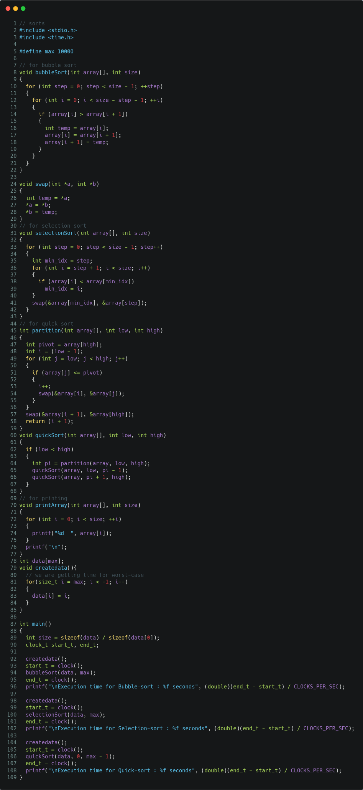

Figure program for different sorting techniques with their execution time.

1. Presentation of Results

Fig 2 shows the output is execution time for worst-case when sorting from 10,000 to 1 in ascending order.

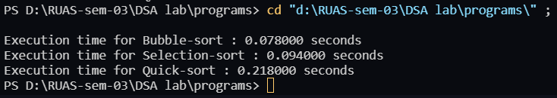

Figure Execution time for different sorting techniques for 10,000 values in worst cases.

Fig 3 shows output for 10 random numbers given by user to check if the sorting algorithms are working properly or not.

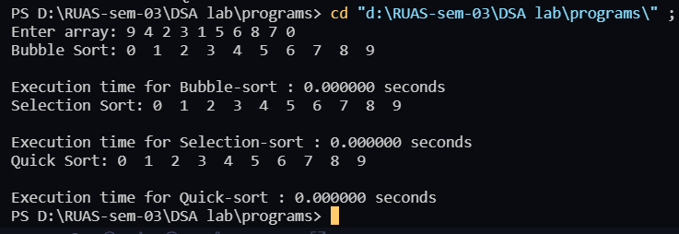

Figure sorting technique for 10 user given inputs and their execution time

**Note**: As shown in Fig 3, for such a small input the execution time is 0 sec.

Actually, the **clock ()** function is not capable of showing precise time up to nano seconds.

It can also be noticed that sorting algorithms are working.

1. Conclusions

Learning happened:

**Bubble sort:**

* Worst Case Time Complexity [ Big-O]: $O(n^{2})$
* Best Case Time Complexity [Big-omega]: $O(n)$
* Average Time Complexity [Big-theta]: $O(n^{2})$
* Space Complexity: $O(1)$

**Selection sort:**

* Worst Case Time Complexity [ Big-O]: $O(n^{2})$
* Best Case Time Complexity [Big-omega]: $O(n^{2})$
* Average Time Complexity [Big-theta]: $O(n^{2})$
* Space Complexity: $O(1)$

**Quick sort:**

* Worst Case Time Complexity [ Big-O]: $O(n^{2})$
* Best Case Time Complexity [Big-omega]: $O(n*log n)$
* Average Time Complexity [Big-theta]: $O(n*log n)$
* Space Complexity: